**WEB FORM ASSIGNMENT**

**Q1. Create a webapge with Registration Form to accept the follwing details from user. Firstname**

**Lastname**

**Mobile number**

**Email Id**

|  |
| --- |
| <!DOCTYPE html>  <html lang="en">  <head>  <meta charset="UTF-8">  <meta name="viewport" content="width=device-width, initial-scale=1.0">  <title>Registration Form</title>  <style> body { font-family: Arial, sans-serif; background-color:#ffffff; margin: 0; padding: 0;  }  h1 { |

**Qualification (Drop down list) (BE, BTech, BSc, BCA)**

**Year of Completion Drop down List (2023, 2022, 2021, 2020)**

**Technicall Skills Drop down List (Web designing, Core Java, Mysql)**

**(Spring, spring Boot with REST API)**

**(core Java)**

**(javascript)**

**Intersted in Relocation (yes/No) submit reset**

**read and submit the data need to be stored in javascript object and in the same page display** **using table.**

text-align: center; padding: 20px 0; }

form { background-color:#8abef6; padding: 20px;

|  |
| --- |
| border-radius: 5px; box-shadow: 0 2px 5px rgba(0, 0, 0, 0.1); max-width: 600px; margin: 0 auto; border: 2px solid rgba(0, 0, 0, 0.1);  } label { font-weight: bold;  } input[type="text"], input[type="tel"], input[type="email"], select, input[type="radio"] { width: 100%; padding: 10px; margin-bottom: 10px; border: 1px solid #ccc; border-radius: 3px;  } select[multiple] { height: auto;  }  input[type="submit"], input[type="reset"] { background-color: #007bff; color: #ffffff; border: none; padding: 10px 20px; cursor: pointer;  } input[type="submit"]:hover, input[type="reset"]:hover { background-color: #0056b3; } |

table { width: 100%; border-collapse: collapse;

margin-top: 20px; border-style: double; border-width: 3px;

}

|  |
| --- |
| th, td { border: 3px solid #090808; padding: 8px; text-align: center;  } th { background-color: #5768c8;  } tr:nth-child(even) {  background-color: #9ec8f7;  }  </style>  </head>  <body>  <h1>Registration Form</h1>  <form id="registrationForm">  <label for="firstname">First Name:</label>  <input type="text" id="firstname" name="firstname" required><br>  <label for="lastname">Last Name:</label>  <input type="text" id="lastname" name="lastname" required><br>  <label for="mobile">Mobile Number:</label>  <input type="tel" id="mobile" name="mobile" required><br>  <label for="email">Email Id:</label>  <input type="email" id="email" name="email" required><br>  <label for="qualification">Qualification:</label>  <select id="qualification" name="qualification">    <option value="BTech">BTech</option>  <option value="BE">BE</option>  <option value="BSc">BSc</option>  <option value="BCA">BCA</option>  </select><br>    <label for="year">Year of Completion:</label> |

<select id="year" name="year">

<option value="2023">2023</option>

<option value="2022">2022</option>

<option value="2021">2021</option> <option value="2020">2020</option>

</select><br>

|  |
| --- |
| <label for="skills">Technical Skills:</label>  <select id="skills" name="skills">  <option value="Web designing">Web designing</option>  <option value="Core Java">Core Java</option>  <option value="Mysql">Mysql</option>  <option value="Spring">Spring</option>  <option value="Spring Boot with REST API">Spring Boot with REST API</option>  <option value="JavaScript">JavaScript</option>  </select><br>    <label for="relocation">Interested in Relocation:</label>  <input type="radio" id="relocationYes" name="relocation" value="Yes" required>  <label for="relocationYes">Yes</label>  <input type="radio" id="relocationNo" name="relocation" value="No" required>  <label for="relocationNo">No</label><br>    <input type="submit" value="Submit">  <input type="reset" value="Reset">  </form>    <table id="dataTable">  <tr>  <th>First Name</th>  <th>Last Name</th>  <th>Mobile Number</th> <th>Email Id</th>  <th>Qualification</th>  <th>Year of Completion</th>  <th>Technical Skills</th>  <th>Interested in Relocation</th>  </tr>  </table>  <script> const registrationForm = document.getElementById("registrationForm"); const dataTable = document.getElementById("dataTable");  registrationForm.addEventListener("submit", function(event) { |

event.preventDefault(); const formData = new FormData(registrationForm);

|  |
| --- |
| const dataObject = {}; formData.forEach((value, key) => { if (key === "skills") { dataObject[key] = Array.from(formData.getAll(key));  } else { dataObject[key] = value;  }  });  const newRow = dataTable.insertRow(); for (const key in dataObject) { const cell = newRow.insertCell(); cell.textContent = dataObject[key];  } registrationForm.reset();  });  </script>  </body>  </html> |

**OUTPUT :**

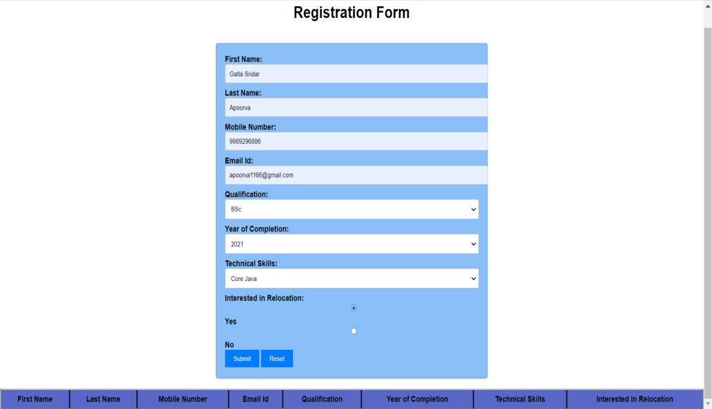

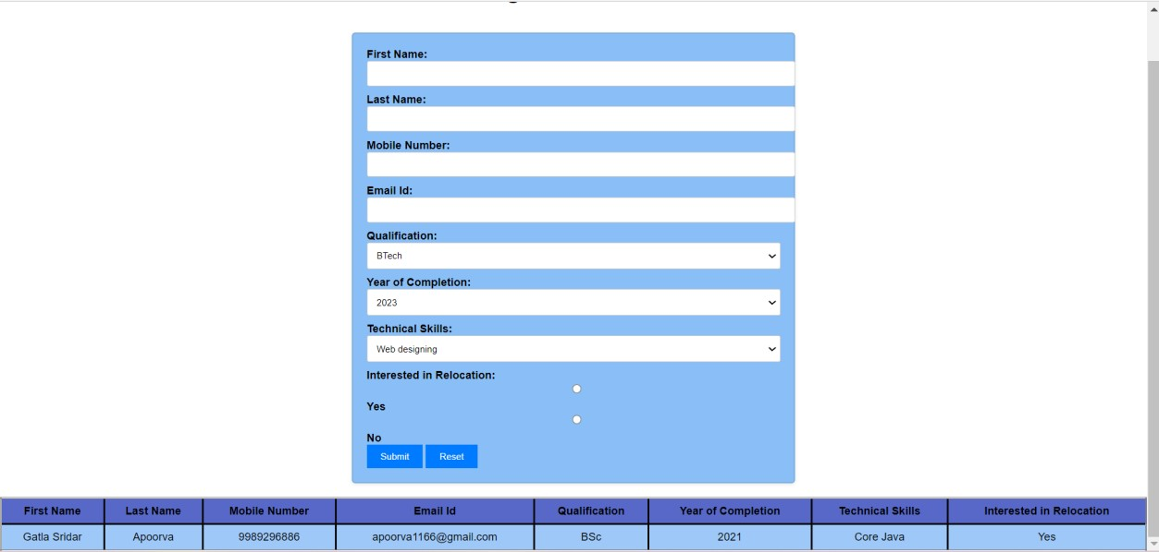

Q2. **Create a webpage using table with Css to write the advantages of Spring boot with explanations.**

|  |
| --- |
| <!DOCTYPE html>  <html lang="en">  <head>  <meta charset="UTF-8">  <meta name="viewport" content="width=device-width, initial-scale=1.0">  <title>Advantages of Spring Boot</title>  <style> body { font-family: Arial, sans-serif; background-color:beige; margin: 0; padding: 0;  } h1 { text-align: center; padding: 20px 0;  }  table { width: 80%; margin: 20px auto; border-collapse: collapse; border: double; border: 3px solid #100f0f; box-shadow: 0 0 10px rgba(0, 0, 0, 0.1); |

|  |
| --- |
| } th, td { padding: 10px; text-align: left;  } th { background-color: #2e27f8;  } tr:nth-child(even) {  background-color: #93b8e7;  }  </style>  </head>  <body>  <h1>Advantages of Spring Boot</h1>  <table>  <tr>  <th>Advantage</th>  <th>Explanation</th>  </tr>  <tr>  <td>1. Rapid Development</td>  <td>Spring Boot simplifies and accelerates application development by providing default configurations and eliminating boilerplate code.</td>  </tr>  <tr>  <td>2. Microservices</td>  <td>Spring Boot is well-suited for building microservices-based architectures, making it easier to develop, deploy, and manage individual components.</td>  </tr>  <tr>  <td>3. Embedded Servers</td>  <td>Spring Boot includes embedded servers like Tomcat and Jetty, making it convenient to package and run applications as standalone JARs.</td>  </tr>  <tr>  <td>4. Opinionated Defaults</td>  <td>Spring Boot provides sensible defaults for various configurations, reducing the need for manual setup and allowing developers to focus on coding.</td>  </tr>  <tr>  <td>5. Auto Configuration</td> |

<td>Spring Boot automatically configures components based on the project's classpath, minimizing the need for explicit configuration.</td>

</tr>

</table>

</body>

</html>

**OUTPUT:**

